Guide to create a free e-signing certificate via video registration

In order to be able to digitally sign different documents that are necessary for your stay at Eötvös Loránd University, you need to possess a qualified e-signing certificate. In case you already have such a certificate issued by an EU trusted provider, you are welcome to use that for e-signing documents. If you do not yet possess an e-signing certificate, you can easily create one free at https://netlock.com/index_en.html.
Netlock provides qualified personal certificate for 2 years duration, with an e-signature accepted in all EU member states. With this certificate you can sign your personal documents as well as send documents to others to sign if needed. Besides the web version there is also a native mobile app for Android and iOS available.

Registration process

The aim of this guide is to help you through the process of registration. For this purpose, the screenshots below were created on the web version.
- After landing on the EN page of Netlock, please push the „REGISTER TO GET IT FOR FREE!” button.
Be sure that is it a simple, self-evident process
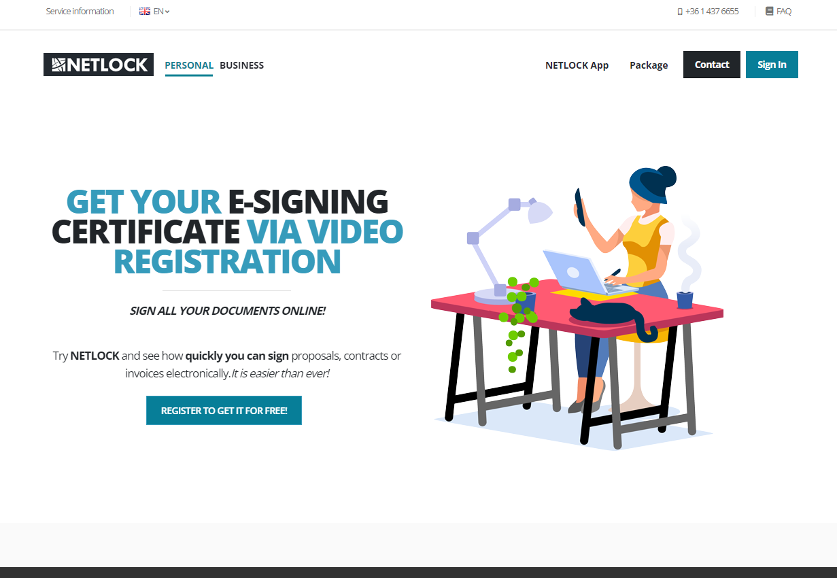

- After carefully reading the „EASY GUIDE” on the right side of the page, please continue by clicking on the „GET YOUR E-SIGNATURE FOR FREE” button.
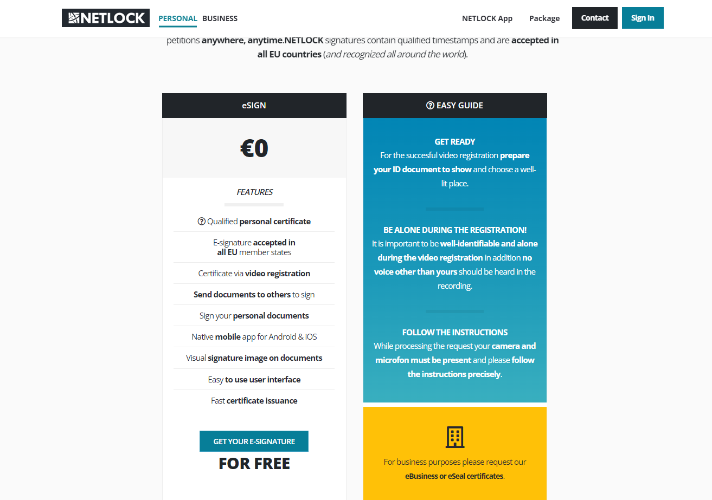

- Now you will need to read and mark as accepted the different contracts that regulates the legal background of registering for a free Netlock e-signing certificate.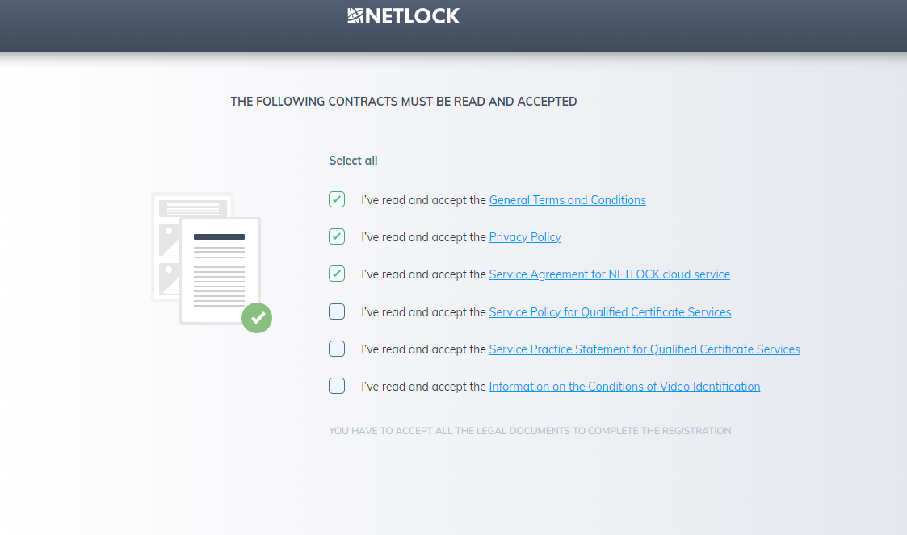

- Now you will need to provide your personal details. Your e-mail address…
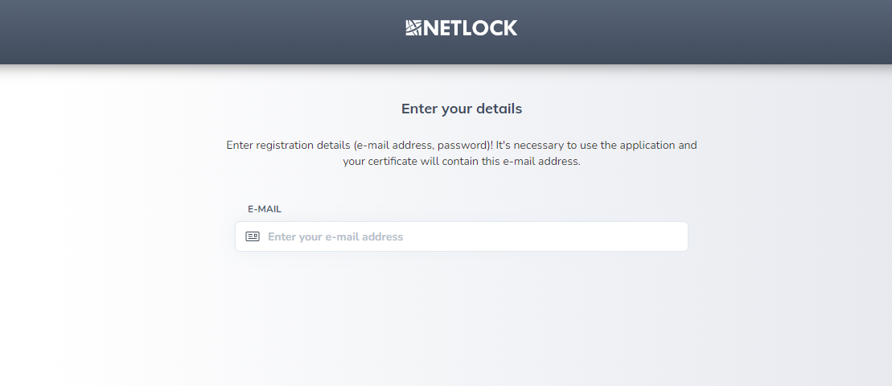

… and the password you are going to use not only for the registration but also for logging in later.
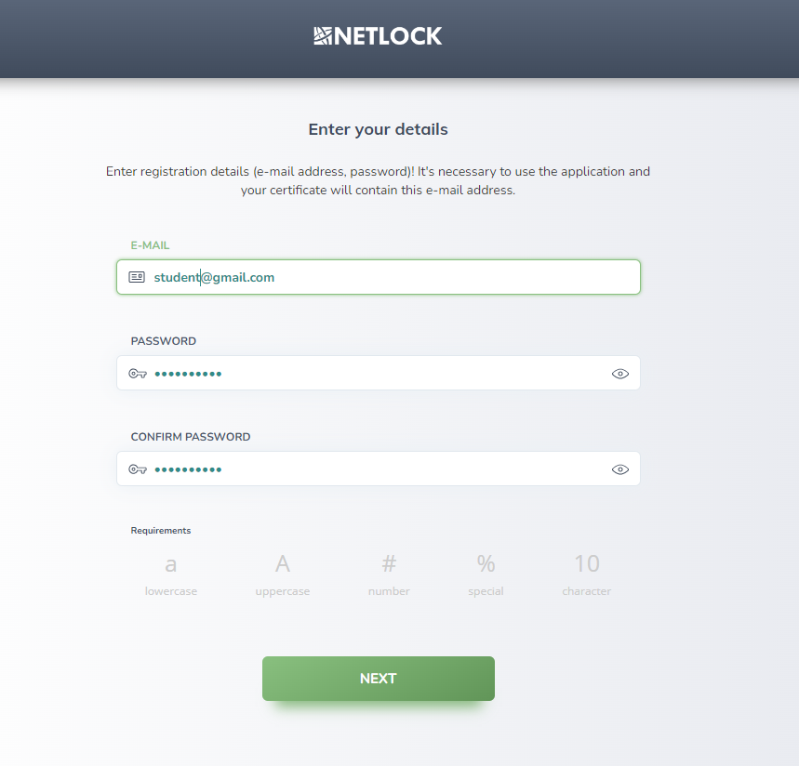
- In this step, you will need to enter the 6-digit activation code that was sent to the email address you provided in the previous step.
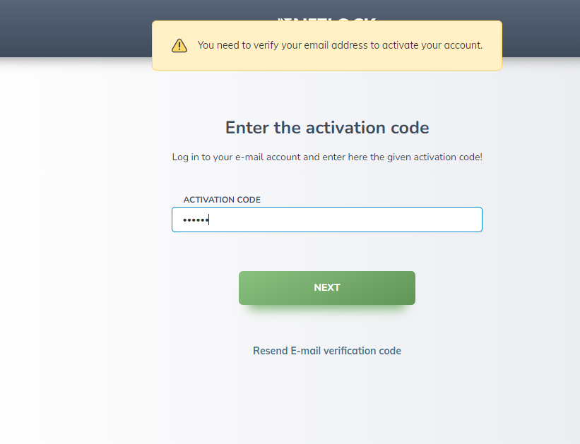

- Now please enter your mobile phone number to meet the two-factor authentication requirements. Please make sure that you carefully select the country code.
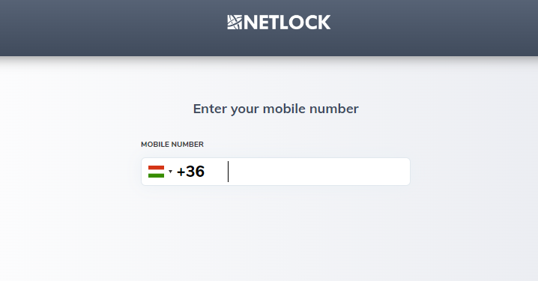
- In this step you need to enter the verification code that was sent to the mobile number you provided in the previous step.
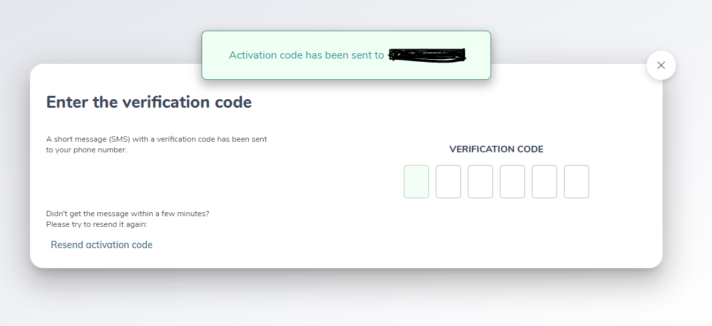

- Please select the issuing country and the type of the document you wish to use for identification.
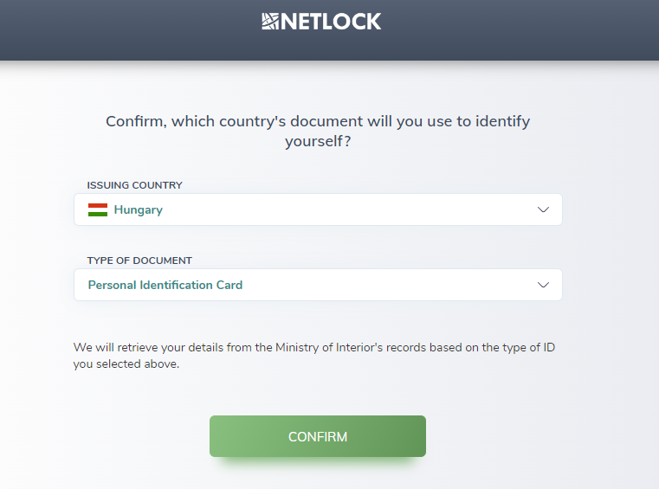

- To start the video identification, please enable access to the webcam and microphone of your device.

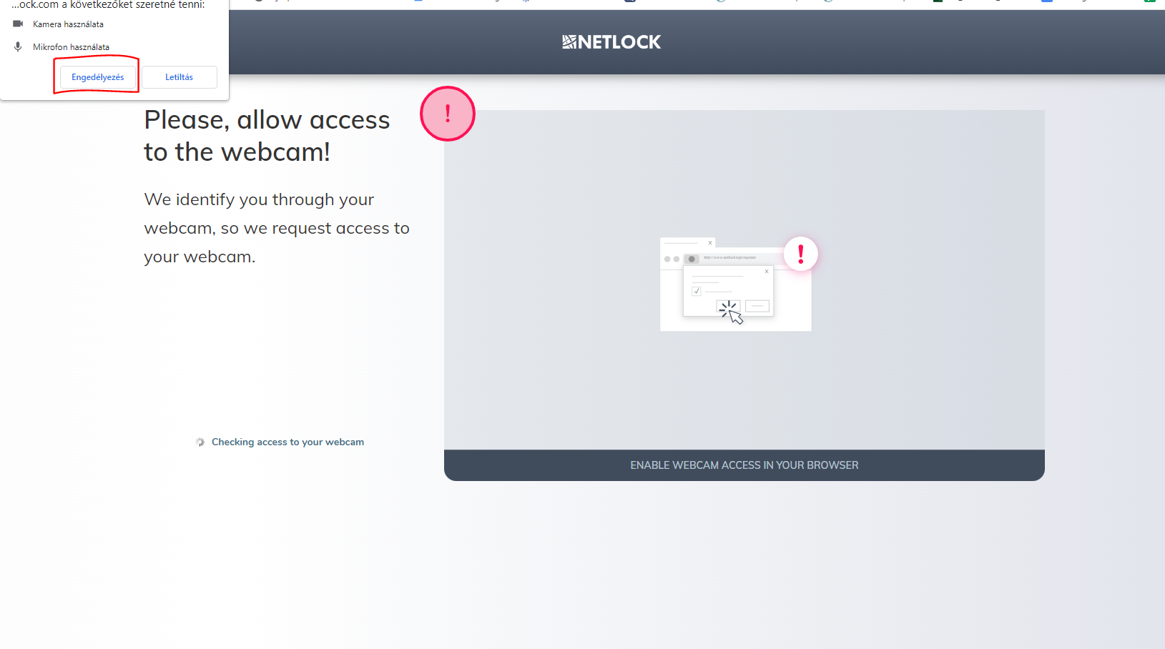

- Before you start the video identification process, you have the opportunity to practice and prepare with the exercises offered by the system.
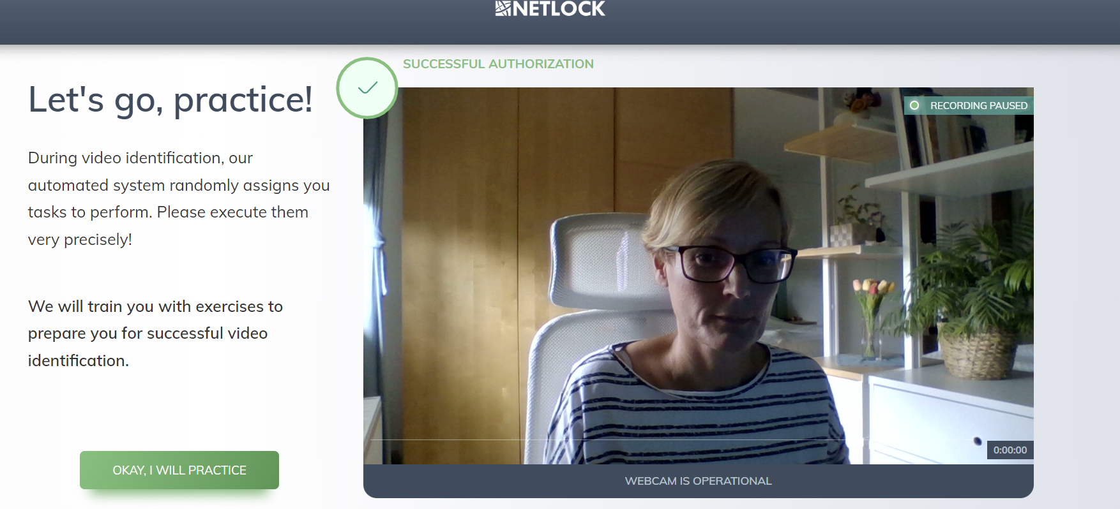

- After practicing, when you feel ready for the video identification process, please carefully follow the tasks randomly assigned to you by Netlock's automated system.

- Once you have completed the video identification process, you must decide whether to share your e-signature capability publicly. Sharing your e-signature capability publicly means that your name and email address will appear on the documents you e-sign as part of the signature properties.
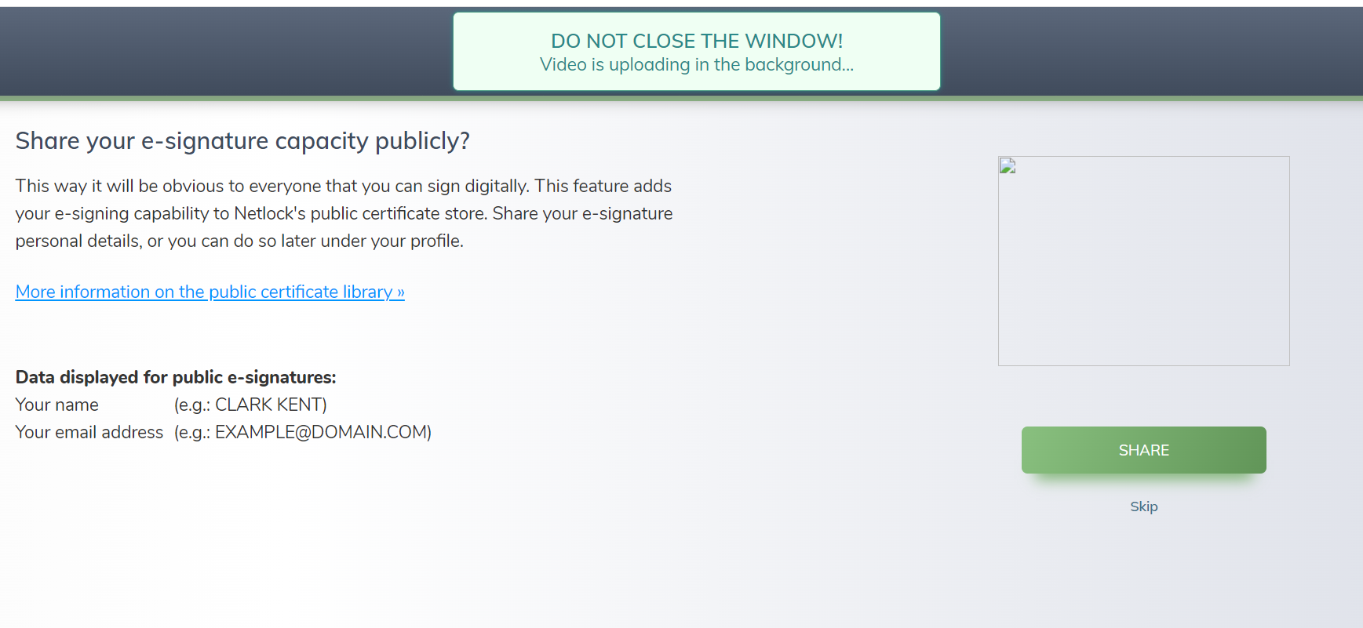

- Once you completed the registration you receive the following system notification.
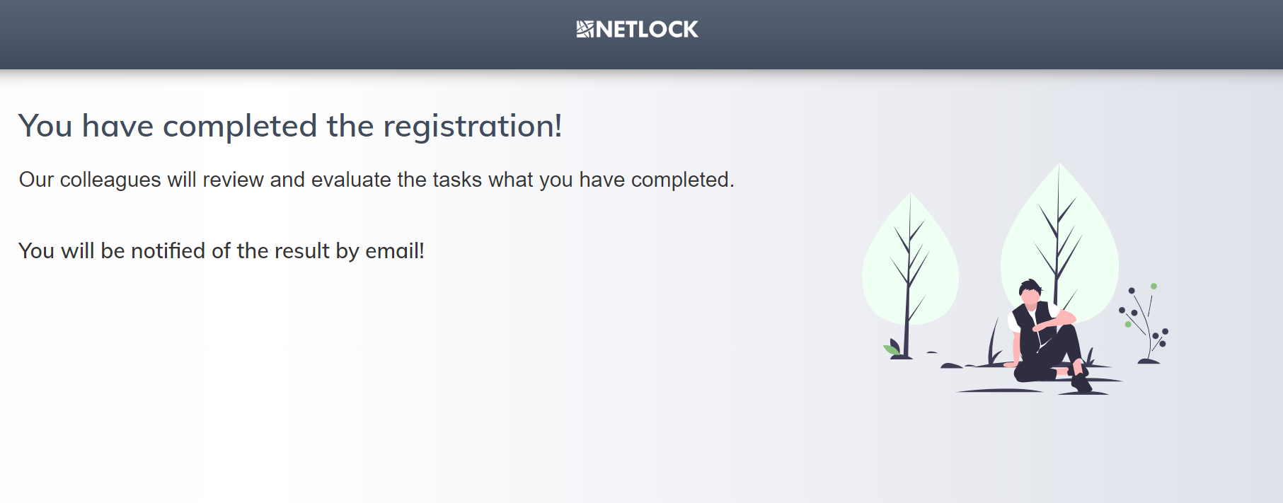

- Now it’s time to check your inbox. You will first receive a notification that the processing of your certificate request started.
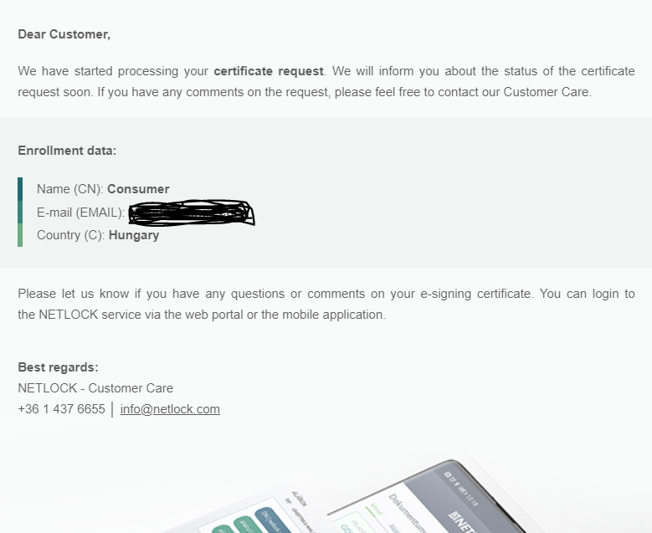

- In a few days’ time the next notification you will receive in your mailbox will inform you that your e-signing certificate has been successfully issued and you can use the electronic signature functionality.
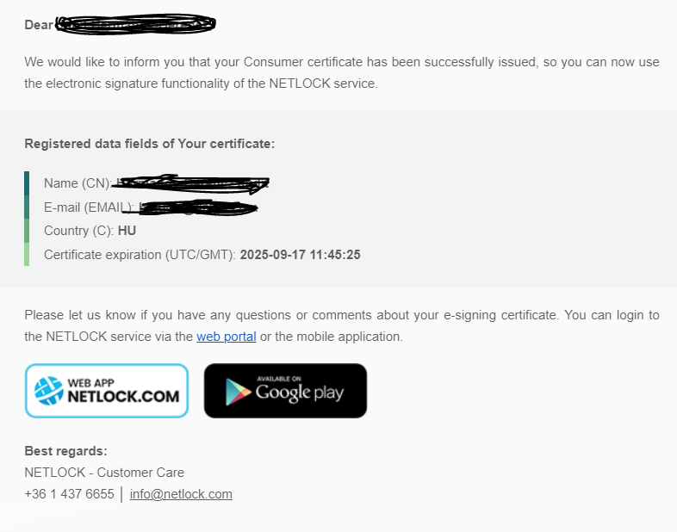

Signing documents

- To use your electronic signature certificate, you will first need to log in/sign in at https://netlock.com/index_en.html or in the native application. To log in, you must use the email address and password you provided during registration.

- By clicking on the “FELTÖLTÉS/UPLOAD” button you will be able to upload the document to be signed. Please note that the document extension must be a pdf file.

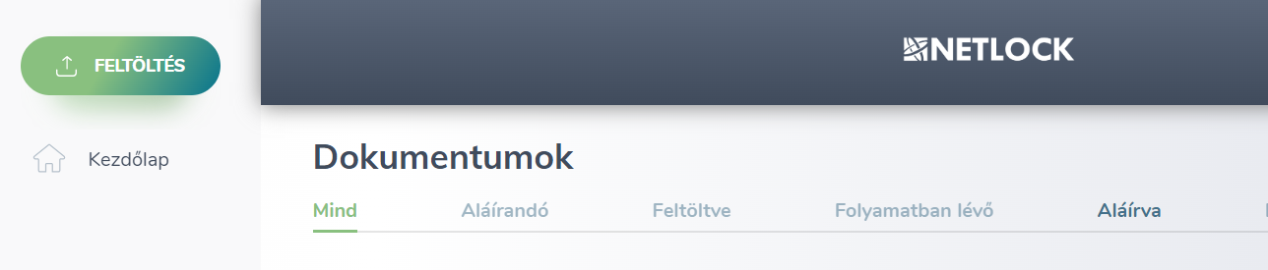

- Now you can start the e-signing process by clicking on the “ALÁÍRÁS KÉRÉSE/REQUEST SIGNATURE” button.
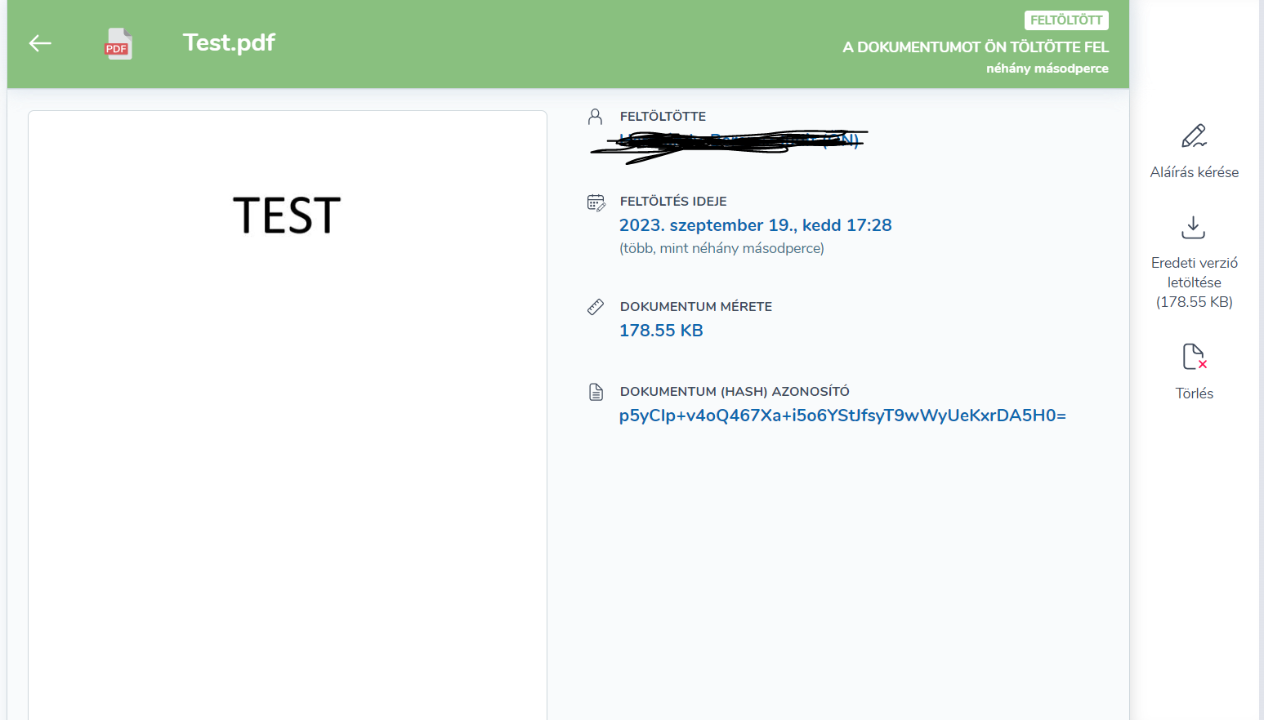

- You must first decide whether you want to ask others to electronically sign the document. If this is the case, please provide the email addresses of those who also need to e-sign the document. Please note that if there are several recipients, you need to separate the e-mail addresses by a space.
If you are the only signer, please click on “Én vagyok az egyetlen aláíró/I am the only signer” link at the bottom of the page.

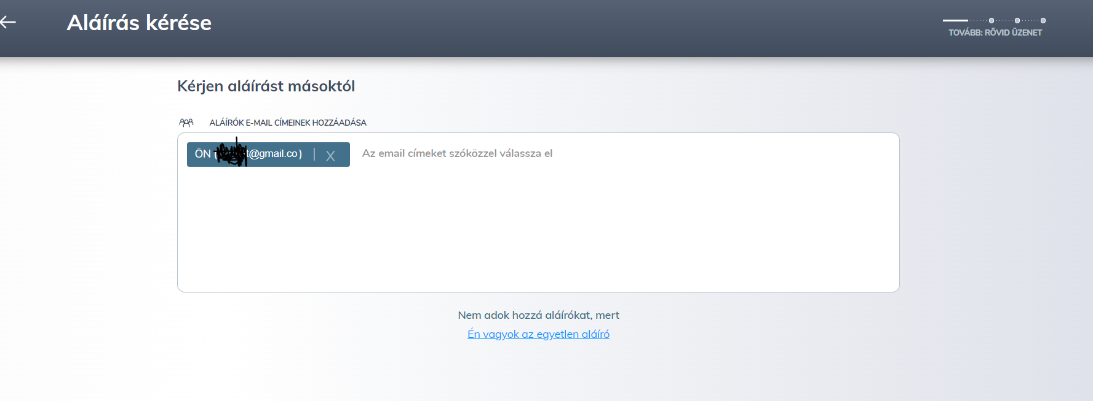

- In this step, you can add the signature image to the document if you wish. Click on the highlighted link to insert the image. (Translation: Add your own siganture image /Click here for position)

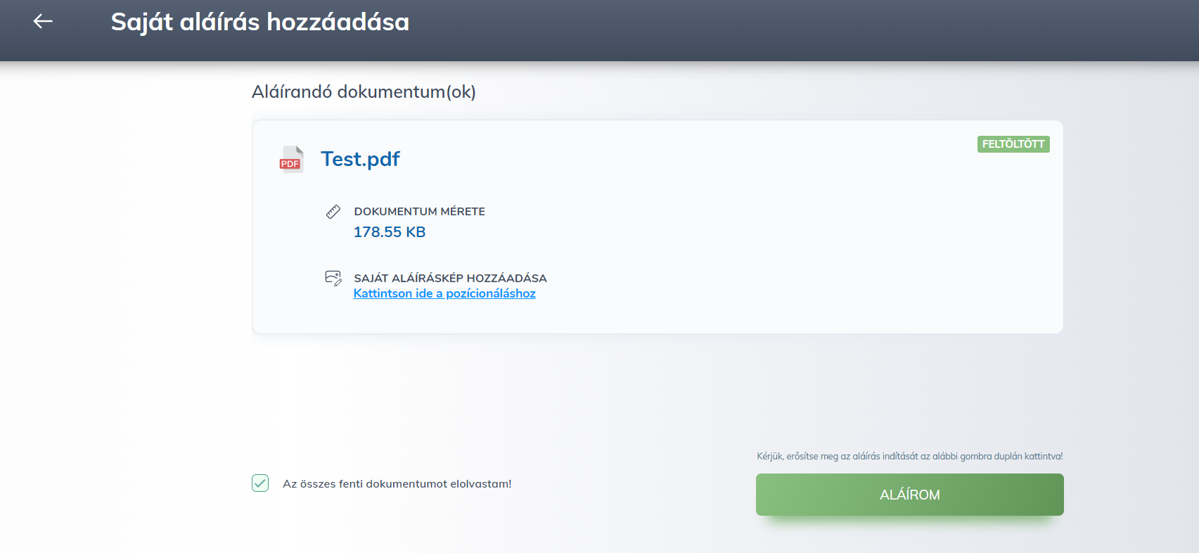

- Now please first tick the checkbox (Translation: “I have read all the above documents”), and then click on the “ALÁÍROM/SIGN IT” button.

- In this step you will need to confirm that all data is correct by clicking on the “MINDEN ADAT RENDBEN VAN/ALL DATA SEEMS TO BE FINE” button.
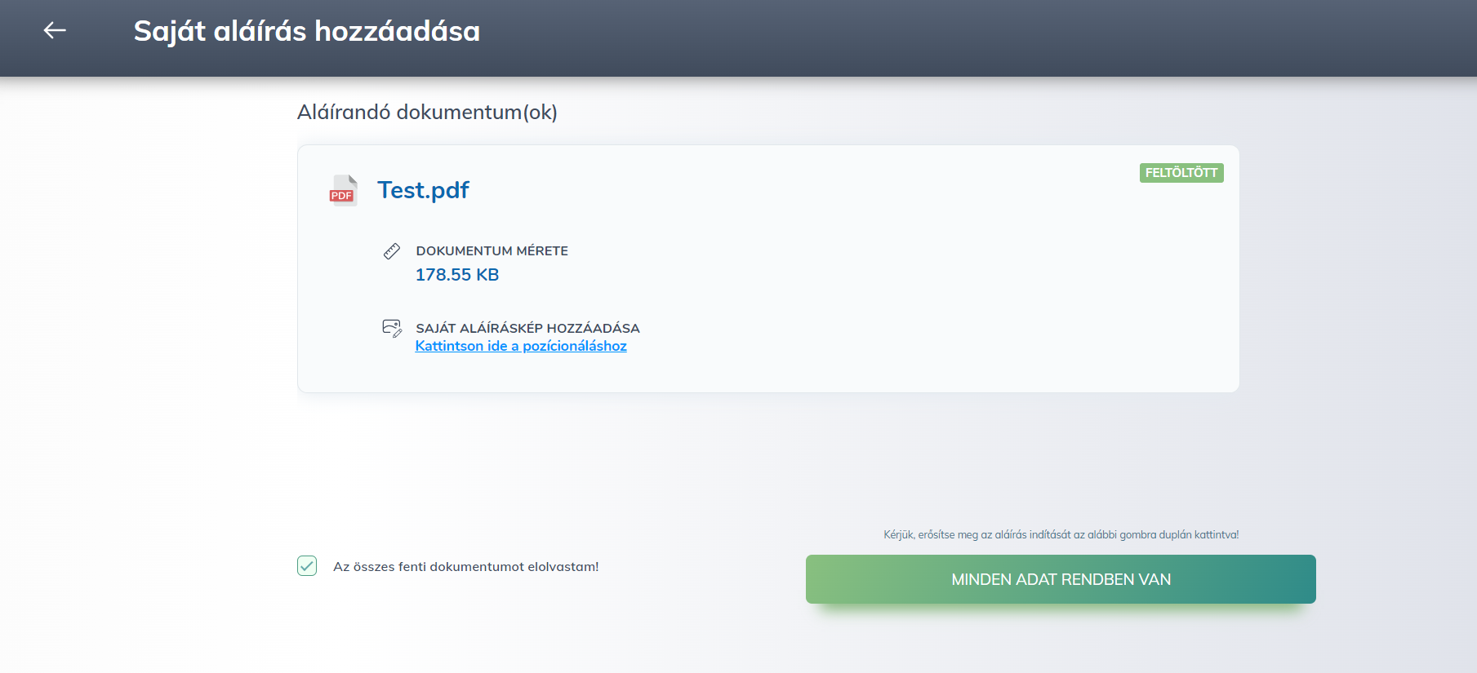

- Please enter the verification code that was sent to the mobile number you provided.

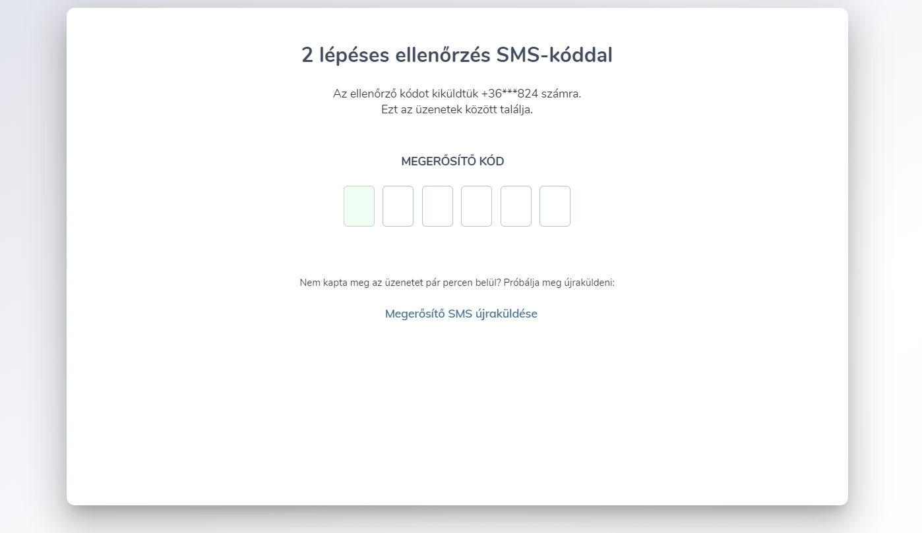

- Please do not leave or close the page until the signature is in progress.
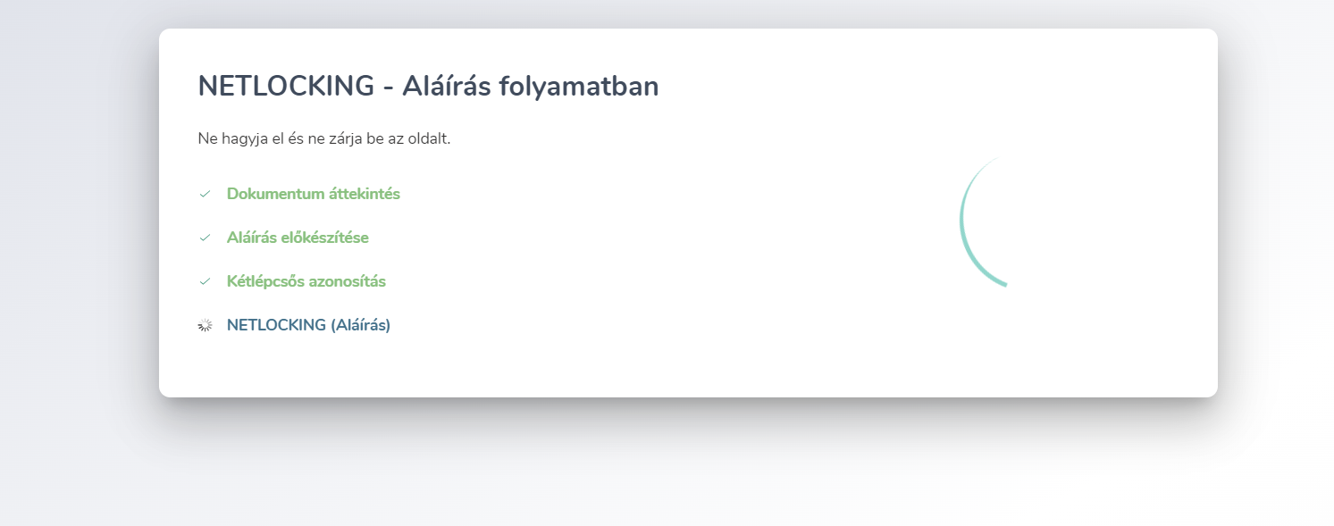

- This screen shows that you have signed the document (Translation: “Signed by you”), so click on the ”OK” button to continue.
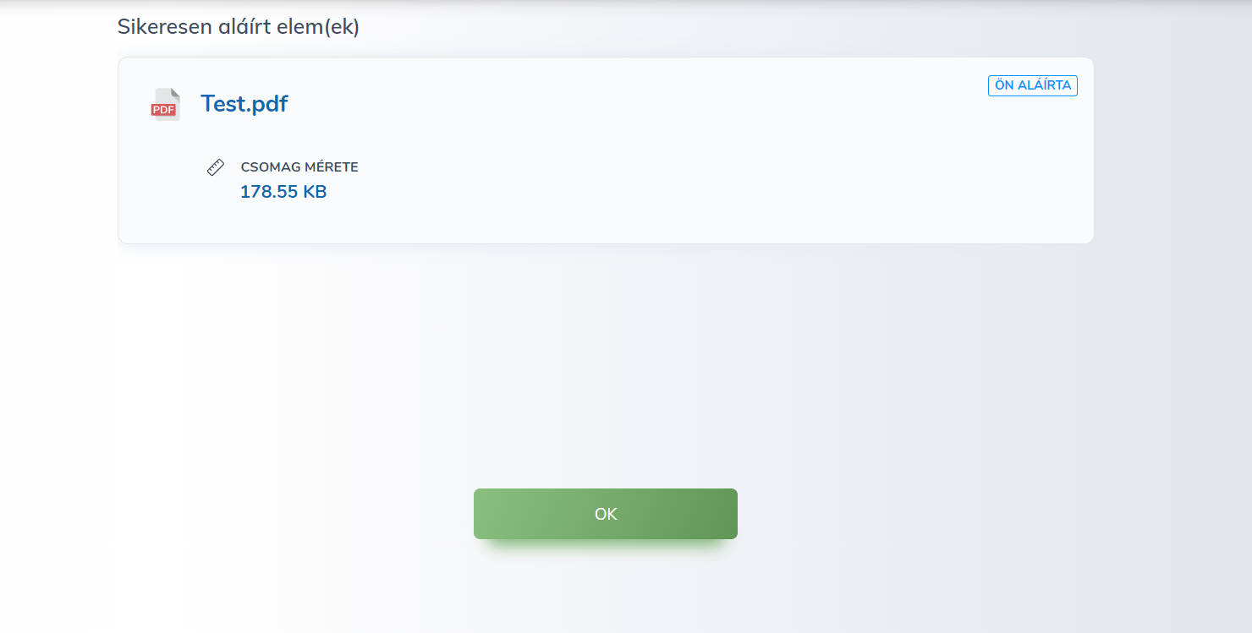

- Now you can check the signed document in the document list.
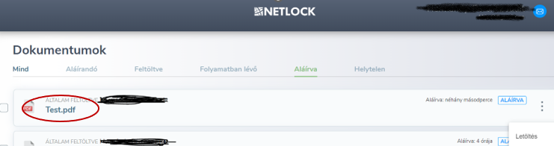
- After opening the signed document, you will see your signature in the signature panel.
